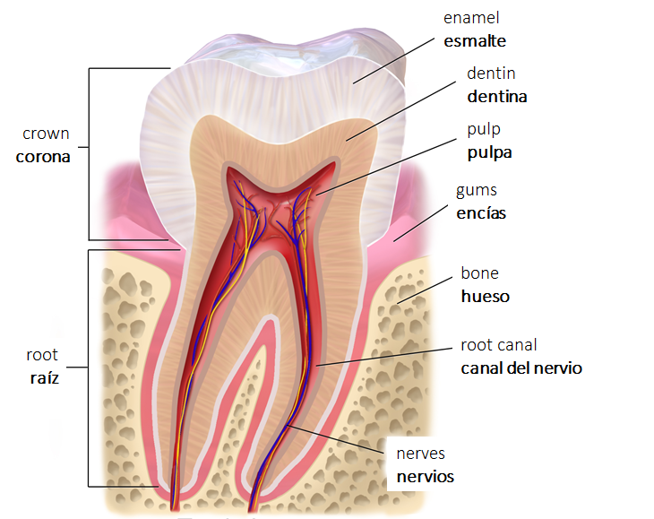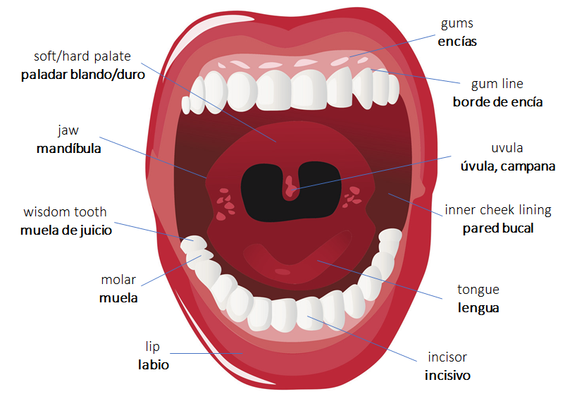

**Common Concerns | Preocupaciones Comunes**

abscess | **abceso**

bad breath | **mal aliento**

cavities | **caries**

decay | **cariado/a, picado/a**

exposed root | **raíz expuesta**

gingivitis | **gingivitis**

periodontal disease | **periodontitis**

overbite | **sobremordida**

underbite | **submordida**

ulcers | **úlceras**

chipped tooth |**diente quebrado**

crooked teeth | **dientes chuecos**

crowded teeth | **dientes amontonados**

excess bleeding | **sangrado excesivo**

false teeth | **dientes postizos**

grinding teeth | **rechinamiento de los dientes**

pockets around teeth | **bolsas alrededor de los dientes**

receding gums | **encías hundidas, retiradas**

sensitive teeth | **dientes sensibles**

**Common Procedures | Procedimientos Comunes**

HYGIENE **| HIGENE**

x-rays | **rayos x**

cleaning | **limpieza**

oral evaluation | **evaluación oral**

scaling & root planning (deep cleaning) | **curetaje y alisado radicular (limpieza profunda)**

fluoride treatment | **tratamiento de floro**

floss | **hilo dental**

sealant | **sellador**

tartar| **sarro**

RESTORATIVE CARE **| CUIDADO RESTAURADOR**

braces | **frenillos, brackets**

bridge | **puente**

crown | **corona**

denture | **dentadura postiza**

extraction | **extracción**

filling | **relleno, tapa,**

**amalgama, curación**

implant | **implante**

retainers | **guarda**

root canal | **tratamiento del nervio, endodocina**

suture | **puntos, puntadas**

**Other Helpful Terms | Otros Términos Útiles**

to bite | **morder**

to grind | **rechinar**

to open/close | **abrir/cerrar**

to polish | **pulir**

to rinse | **enjuagar**

to seal | **tapar, rellenar**

to scrape | **raspar**

to spit out | **escupir**

to stick tongue out | **sacar la lengua**

to swell | **hinchar**

acute | **agudo**

allergy | **alergia**

anesthesia | **anestesia**

drill | **taladro**

inflammation | **inflamación**

risk of infection | **riesgo de infeción**

rubber dam | **dique de goma**

suction | **extractor de saliva**

syringe | **jeringuilla, aguja**

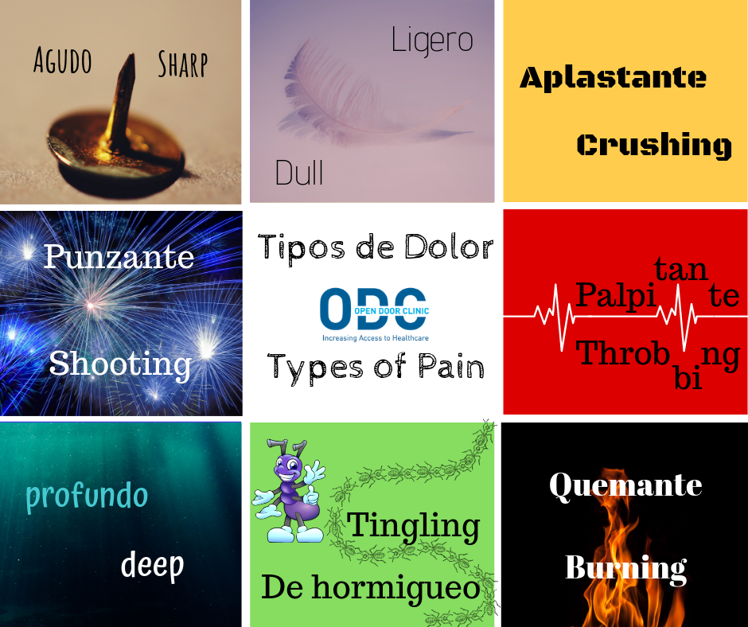

|  |  |  |  |  |
| --- | --- | --- | --- | --- |
| Agacharse | | Bend over | | |
| Agudo (dolor) | | Sharp (pain) | | |
| Alergia de la piel, erupción | | Rash | | |
| Amígdalas | | Tonsils | | |
| Ampolla, roncha | | Blister (sore) | | |
| Ano | | Anus | | |
| Antebrazo | | Forearm | | |
| Apéndice | | Appendix | | |
| Arco | | Arch | | |
| El ardor | | Burning | | |
| Artéria | | Artery | | |
| Asma | | Asthma | | |
| Barba, mentón, barbilla | | Chin | | |
| Barriga, vientre, abdomen | | Abdomen | | |
| Bazo | | Spleen | | |
| Benigno | | Benign | | |
| Boca | | Mouth | | |
| Cabeza | | Head | | |
| Cadera | | Hip | | |
| Calambre | | Cramp | | |
| Cara | | Face | | |
| Cartílago | | Cartilage | | |
| Ceja | | Eyebrow | | |
| Célula | | Cell | | |
| Cerebro | | Brain | | |
| Cerilla | | Ear wax | | |
| Cintura | | Waist | | |
| Cita de seguimiento | | Follow-up appointment | | |
| Coágulo de sangre | | Blood clot | | |
| Codo | | Elbow | | |
| El colesterol | | Cholesterol | | |
| Colilla de cheque | | Check stub | | |
| Colon | | Colon | | |
| Columna vertebral, médula espinal | | Spinal cord | | |
| Comezón, picazón | | Itching | | |
| Cordón umbilical | | Umbilical cord | | |
| Costilla | | Rib | | |
| Coyuntura | | Joint | | |
| Cráneo | | Skull | | |
| Cuello del útero | | Cervix | | |
| Cuello, pescuezo | | Neck | | |
| Cuerdas vocales | | Vocal cords | | |
| Cuñado / cuñada | | Brother / sister-in-law | | |
| Dedo | | Finger | | |
| Dedo anular | | Ring finger | | |
| Dedo del pie | | Toe | | |
| Dedo índice | | Index finger | | |
| Dedo medio | | Middle finger | | |
| Dedo pulgar, dedo gordo | | Thumb | | |
| Dentadura, prótesis | | Denture | | |
| Derrame cerebral | | Stroke | | |
| Diabetes | | Diabetes | | |
| Diafragma | | Diaphragm | | |
| Diente | | Tooth | | |
| En ayunas | | With an empty stomach, fasting | | |
| Encías | Gums | |
| Enfermera practicante / E. especializada | Nurse practitioner | |
| Es usted alérgico a cualquier medicación? | Are you allergic to any medication? | |
| Escroto | Scrotum | |
| Esófago | Esophagus | |
| Espalda | Back | |
| Estómago, barriga | Stomach | |
| Estornudar | Sneeze | |
| Estremecimiento | Tingling | |
| Estreñido | Constipated | |
| Estreñimiento | Constipation | |
| El examen, el chequeo | Exam, examination, checkup | |
| Falta de respiración | Shortness of breath | |
| Faringe | Pharynx | |
| Físico, física | Physical | |
| Frente | Forehead | |
| Garganta | Throat | |
| General | General | |
| Glándula | Gland | |
| Glándula tiroides | Thyroid gland | |
| Gotas | Drops | |
| Grasa (noun); gordo/gorda (adj) | Fat | |
| Hacer un análisis, hacer una prueba | To run a test | |
| Hacer un examen | To give a checkup | |
| Heces fecales | Stool | |
| Hernia | Hernia | |
| Hígado | Liver | |
| Hinchazón | Swelling | |
| Histerectomía, extirpación del útero | Hysterectomy | |
| Hombro | Shoulders | |
| Hueso | Bone | |
| Infección de las vías urinarias | UTI (urinary tract infection) | |
| Insulina | Insulin | |
| Intestino | Bowel | |
| Jeringa, jeringuilla | Syringe | |
| Ligadura o ligazón de las trompas | Tubal ligation | |
| Lóbulo de la oreja | Earlobe` | |
| Maligno | Malignant | |
| Mamograma, mamografía | Mammogram | |
| Mano | Hand | |
| Mejílla | Cheek | |
| Mambrana | Membrane | |
| Mente | Mind | |
| Moretón, morete | Bruise | |
| Mucosidad, flema | Mucus | |
| Muñeca | Wrist | |
| Músculo | Muscle | |
| Muslo | Thigh | |
| Naris, fosa nasal | Nostril | |
| Nariz | Nose | |
| Negativo, negativa | Negative | |
| Nervio | Nerve | |
| Normal | Normal | |
| Ojo | Eye | |
| Ombligo | Navel | |
| Oreja (external); oído (internal) | Ear | |
| Órgano | Organ | |
| Osteoporosis | Osteoporosis | |
| Ovário | Ovary | |
| Palma | Palm (hand) | |
| Pantorrilla | Calf | |
| Exame de Papanicolaou | Pap Smear | |
| Paperas | Mumps | |
| Pastilla anticonceptiva | Birth control pill | |
| Pecho | Chest | |
| Pelo, cabello | Hair | |
| Pelvis | Pelvis | |
| Pene | Penis | |
| Perineo | Perineum | |
| Pestaña | Eyelash | |
| Pezón | Nipple | |
| Pie | Foot | |
| Piel | Skin | |
| Planificación familiar | Family Planning | |
| Planta del piel | Sole (foot) | |
| Por la boca | Through the mouth | |
| Positivo, positiva | Positive | |
| La presión | Pressure | |
| Presión arterial / presión de sangre | Blood Pressure | |
| Próstata | Prostate | |
| Prueba de embarazo | Pregnancy test | |
| Prueba de hogar, prueba de dirección | Proof of address | |
| Prueba de ingresos | Proof of income | |
| Prueba de orina | Urine sample | |
| Prueba o análisis de sangre | Blood test | |
| Prueba tuberculina | PPD / TB test | |
| Pulmón | Lung | |
| Pulso | Pulse | |
| Receta médica | Prescription | |
| Recto | Rectum | |
| Respire hondo, profundo | Take a deep breath, breathe deeply | |
| El resultado | Result | |
| Riñon | Kidney | |
| Rodilla | Knee | |
| Ronchas, urticaria | Hives | |
| Ronco, ronca | Hoarse | |
| El ruido | Noise, ringing | |
| Sano, sana | Healthy | |
| Saque la lengua | Stick out the tongue | |
| Sarampión | Measles | |
| Seno | Breast | |
| Sintoma | Symptom | |
| Sinus | Sinus | |
| Soplo cardíaco | Heart murmur | |
| Subir de peso, aumentar de peso | To gain weight | |
| Talón | Heel | |
| T-de-cobre, dispositivo | IUD | |
| Tejido | Tissue | |
| Tendón | Tendon | |
| Testículo | Testicle | |
| Tobillo | Ankle | |
| Torcer | Sprain | |
| Toser (tos) | Cough |
| Tragar | Swallow |
| Tráquea | Trachea |
| Trompas de falopio | Fallopian tube |
| Tumor | Tumor |
| Un silbido | Wheezing |
| Uña | FIngernail |
| Uréter | Ureter |
| Uretra | Urethra |
| Útero, matriz | Uterus (womb) |
| Vagina | Vagina |
| Varicela | Chicken pox |
| Vaso sanguíneo | Blood vessels |
| Vejíga | Bladder |
| Vena | Vein |
| Vértebra | Vertebra |
| Vesícula | Gallbladder |
| Vista nublada | Blurred vision |
| Yerno / yerna | Son / daughter-in-law |
| Yeso | Cast (on a limb) |
| Zumbido en los oídos | Ringing in the ears |
| **Dental List** | |
| Absceso | Abscess |
| La abrasión | Abrasion |
| Los frenillos | Braces |
| Las caries | Cavities |
| La corona | Crown |
| El diente canino | Cuspid |
| El / la dentista | Dentist |
| La dentadura postiza | Denture |
| El drenaje | Drainage |
| Diente de leche | Baby tooth |
| El esmalte | Enamel |
| La extracción | Extraction |
| El fluór | Fluoride |
| La encía | Gum |
| El implante | Implant |
| Infectado | Infected |
| La mandíbula | Jaw |
| La muela | Molar |
| La boca | Mouth |
| El nervio | Nerve |
| El paladar | Palate |
| Permanente | Permanent |
| El sarro, la placa dental | Plaque |
| La resina | Resin |
| Enjuagar | Rinse |
| La raíz | Root |
| La endodoncia | Root canal |
| Encía sensitiva | Sensitive gum |
| Dientes sensibles | Sensitive teeth |
| Sensibilidad | Sensitivity |
| Hinchazón | Swelling |
| El relleno | Filling |
| Relleno provisional / relleno temporal | Temporary filling |
| La lengua | | Tongue | | |
| La cordal / la muela del juicio | | Wisdom tooth | | |
| Levadura / hongos | | Yeast | | |

**Prefixes**

|  |  |  |
| --- | --- | --- |
| **Prefix** | **Meaning** | **Example** |
| an- | without | anemia |
| anti- | against | antitoxin |
| auto- | self | autoimmune |
| contra- | against | contraindication |
| dys- | abnormal, difficult | dysfunctional |
| endo- | within, inside | endoscopy |
| extra- | outside of | extraventricular |
| hemi- | half | hemiglossectomy |
| hyper- | above, increased | hyperplasia |
| hypo- | under, decreased | hypodermic |
| infra- | below, beneath | infrared |
| inter- | between | intercostals |
| mal- | bad, poor | malnutrition |
| macro- | large | macrocephalia |
| micro- | small | microscope |
| multi- | many | multiparous |
| neo- | new | neonatal |
| peri- | around | perinatal |
| poly- | many | polyneuritis |
| post- | after | postpartum |
| pre- | before | preeclampsia |
| pro- | before, for, on account of | prolapse |
| pseudo- | false | pseudocyesis |
| retro- | backward | retroperitoneal |
| sub- | under, beneath | subcutaneous |
| uni- | one | unilateral |

**Roots**

|  |  |  |
| --- | --- | --- |
| **Root** | **Meaning** | **Example** |
| arthr | joint | arthrocentesis |
| aden/o | having to do with glands | adenopathy |
| carcin/o | cancerous | carcinoma |
| cardi/o | having to do with the heart | cardiograph |
| cephal/o | head | cephalic |
| dermat/o | skin | hypodermic |
| enter/o | intestines | enteritis |
| gast/o | having to do with the digestive tract | gastritis |
| gynec/o | woman, female | gynecology |
| hem/o | having to do with blood | hemodialysis |
| iatr/o | practice of healing | pediatric |
| my/o | muscle | myofibril |
| nephr/o | kidney | nephrology |
| neur/o | having to do with the nerves | neuralgia |
| oste/o | bone | osteopathy |
| orth/o | straight, normal | orthotics |
| ophthalm/o | having to do with the eye | ophthalmoscope |
| ot/o | having to do with the ear | otoscope |
| path/o | disease | pathology |
| ped/o | child | pediatrics |
| psych/o | mind | psychiatrist |
| ur/o | urine | uric acid |
| therm/o | heat | thermometer |

**Suffixes**

|  |  |  |
| --- | --- | --- |
| **Suffixes** | **Meaning** | **Example** |
| -algia | pain | neuralgia |
| -cide | destructive, killing | bactericide |
| -ectomy | surgical removal of | tonsillectomy |
| -emia | blood | anemia |
| -graphy | process of recording | cardiography |
| -gram | record | angiogram |
| -itis | inflammation | bronchitis |
| -ist | person who practices something | nephrologist |
| -logy | study of | dermatology |
| -oma | tumor | sarcoma |
| -opsy | to view | biopsy |
| -osis | disease, condition | lymphocytosis |
| -ostomy | opening to form a mouth | colostomy |
| -pathy | disease | neuropathy |
| -phobia | fear | hydrophobia |
| -plasia | formation, growth | dysplasia |
| -plegia | paralysis | paraplegia |
| -scope | instrument for visual examination | otoscope |
| -tomy | incision of | laparotomy |

**Helpful words / cognates**

|  |  |
| --- | --- |
| Apretar (e:ie) | To press (down) |
| Así | Like this, so |
| Bajo, baja | Low |
| Correr | To run |
| Cuando | When |
| Deprisa | In a hurry |
| Dentro de | In, within |
| La dificultad | Difficultly |
| Doblar | To bend |
| Doler (o:ue) | To hurt, ache |
| Dormir (o:ue) | To sleep |
| Este, esta | This |
| Fuera de lo común | Out of the ordinary |
| Hacia adelante | Forward |
| Hacia atrás | Backward |
| Hasta | Until, till |
| Lentamente | Slowly |
| Lo mismo | The same (thing) |
| Más o menos | More or less |
| Nada | Nothing |
| Otra vez | Again |
| Parecer | To seem |
| Respirar, resollar | To breathe |
| Sentir (e:ie) | To feel |
| Separar | To separate |
| Sin | Without |
| Tocar | To touch |
| Traer | To bring |
| Un poco | A little |